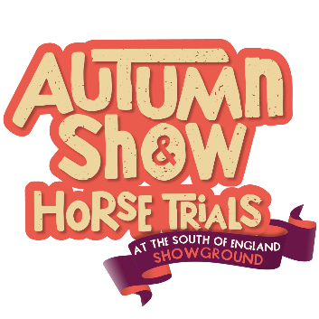
Caption the photograph competition (Facebook, Instagram & Tiktok)
How to Enter
Like the caption competition post, follow our page and comment your suggested caption to be in with a chance to win family tickets for the Autumn Show & Horse Trials, and a lunch during our Sunday show. Entry is open until midnight Monday 18/9/26 after which date three winners will be selected by a panel from the South of England Agricultural Society. The winners will be notified by 22/9/26.
Terms & Conditions
- You will be entered into a free competition when you like our post, follow our page and comment a caption for the photograph.
- Winners must be over 18 years of age and a resident in the UK. Employees of the South of England Agricultural Society (SEAS), their families, agents or anyone else connected with this promotion, are not eligible to win.
- By entering, the participant agrees to be bound by these Terms and Conditions.
- Ticket terms and conditions apply. There are 3 family tickets to be won including 2 adults tickets and up to 4 children’s tickets each. Under 16’s go free if accompanied by a ticket holder. Family ticket value based on 2026 prices is £32 (excluding advance discount). The Autumn Show & Horse Trials will take place from Saturday 26th – Sunday 27th September 2026. If selected, you must let us know which day you would like to attend and how many tickets you require.
- The winner will be selected after 18/9/26, when the competition closes.
- A panel of SEAS Staff will select their favourite 3 captions from all entries.
- The winnesr and chosen caption will be notified publicly via the social media platform they used to enter the competition.
- Tickets must be claimed within 72 hours of being notified. If tickets are not claimed within 72 hours another winner will be selected.
- SEAS accepts no responsibility for any costs associated with the prize and not specifically included in the ticket price (including, without limitation, travel to and from the event).
- The prize is not transferable and no cash alternative is available.
- If you are a winner, SEAS may request that you participate in publicity or promotion organised by SEAS including promotional photographs in relation to this competition.
- SEAS accepts no responsibility for any damage, loss, liabilities injury or disappointment incurred or suffered by you as a result of entering the prize draw, accepting the prize or attending the event.
- SEAS reserves the right to withdraw this offer or amend these Terms and Conditions at any time without notice.
- In the event of any dispute regarding the Terms and Conditions, the conduct, results and any other matters relating to this prize draw, the decision of SEAS shall be final and no correspondence or discussion shall be entered into.
- You may enter as many times as you wish.
- The information you provide in relation to your competition entry will be used for this competition only and will not be shared with any other party outside the South of England Agricultural Society and will not be used for other purposes in future dealings.

